Programming Assignment #
Name: Amna Malik ID: R11827604
Problem-1
(Your Codes)
package parts;
import java.util.Scanner;
/**
* Converts a number from 1 to 90 into Roman numerals.
*/
public class parta {
/*
* Turns a number into Roman numerals
*/
public static String toRoman(int number) {
// Stores final Roman numeral
String roman = "";
// Roman numeral values
int[] values = {90, 50, 40, 10, 9, 5, 4, 1};
// Roman numeral symbols
String[] numerals = {"XC", "L", "XL", "X", "IX", "V", "IV", "I"};
// Builds the Roman numeral string
for (int i = 0; i < values.length; i++) {
while (number >= values[i]) {
roman += numerals[i];
number -= values[i];
}
}
return roman;
}
/*
* Runs the program and handles user input/output
*/
public static void main(String[] args) {
// Used for input
Scanner scanner = new Scanner(System.in);
// Stores user number
int number;
// Keep asking until valid
while (true) {
System.out.print("Enter a number 1 to 90: ");
number = scanner.nextInt();
if (number >= 1 && number <= 90) {
break;
}
System.out.println("Sorry, that choice is invalid. Please try again.");
}
// Stores Roman numeral result
String romanNumeral = toRoman(number);
// Prints result
System.out.println("Roman Numeral of " + number + ": " + romanNumeral);
scanner.close();
}
}

(Output- screenshots)
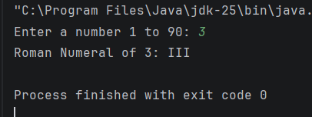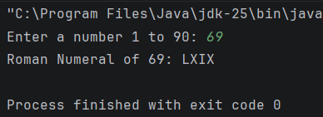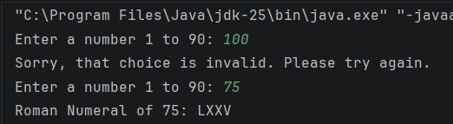

Problem-2
(Your Codes)
package parts;
import java.util.Scanner;
/**
* Gets 3 names and prints them in alphabetical order.
*/
public class partb {
/*
* Sorts three names A to Z
*/
public static String[] sortNames(String a, String b, String c) {
// Holds the three names
String[] names = {a, b, c};
// Swap first two if needed
if (names[0].compareToIgnoreCase(names[1]) > 0) {
String temp = names[0];
names[0] = names[1];
names[1] = temp;
}
// Swap last two if needed
if (names[1].compareToIgnoreCase(names[2]) > 0) {
String temp = names[1];
names[1] = names[2];
names[2] = temp;
}
// Check first two again
if (names[0].compareToIgnoreCase(names[1]) > 0) {
String temp = names[0];
names[0] = names[1];
names[1] = temp;
}
return names;
}
/*
* Runs the program and prints sorted names
*/
public static void main(String[] args) {
// Used for input
Scanner scanner = new Scanner(System.in);
// First name
System.out.print("Type the first name: ");
String first = scanner.nextLine();
// Second name
System.out.print("Type the second name: ");
String second = scanner.nextLine();
// Third name
System.out.print("Type the third name: ");
String third = scanner.nextLine();
// Sorted result
String[] sorted = sortNames(first, second, third);
// Print output
System.out.println("Here are the names in order:");
System.out.println("1. " + sorted[0]);
System.out.println("2. " + sorted[1]);
System.out.println("3. " + sorted[2]);
scanner.close();
}
}

(Output- screenshots)
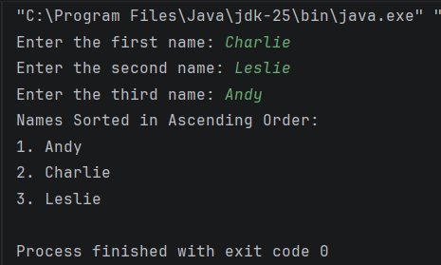
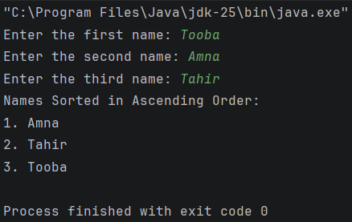

Problem-3
(Your Codes)
package parts;
import java.util.Scanner;
/**
* Helps walk through fixing Wi-Fi problems.
*/
public class partc {
/*
* Checks if input means yes
*/
public static boolean saidYes(String input) {
// Cleaned input
String text = input.trim().toLowerCase();
return text.equals("yes") || text.equals("y");
}
/*
* Runs the troubleshooting steps
*/
public static void main(String[] args) {
// Used for input
Scanner scanner = new Scanner(System.in);
// User response
String reply;
// Step 1
System.out.println("Reboot the computer and try to connect.");
System.out.print("Did that fix the problem? ");
reply = scanner.nextLine();
if (saidYes(reply)) {
scanner.close();
return;
}
// Step 2
System.out.println("Restart the router and try to connect.");
System.out.print("Did that fix the problem? ");
reply = scanner.nextLine();
if (saidYes(reply)) {
scanner.close();
return;
}
// Step 3
System.out.println("Check that the modem and router cables are plugged in.");
System.out.print("Did that fix the problem? ");
reply = scanner.nextLine();
if (saidYes(reply)) {
scanner.close();
return;
}
// Step 4
System.out.println("Move the router somewhere else.");
System.out.print("Did that fix the problem? ");
reply = scanner.nextLine();
if (saidYes(reply)) {
scanner.close();
return;
}
// Final step
System.out.println("You may need a new router.");
scanner.close();
}
}

(Output-screenshots)
